Bacon Brown Sugar Garlic Chicken
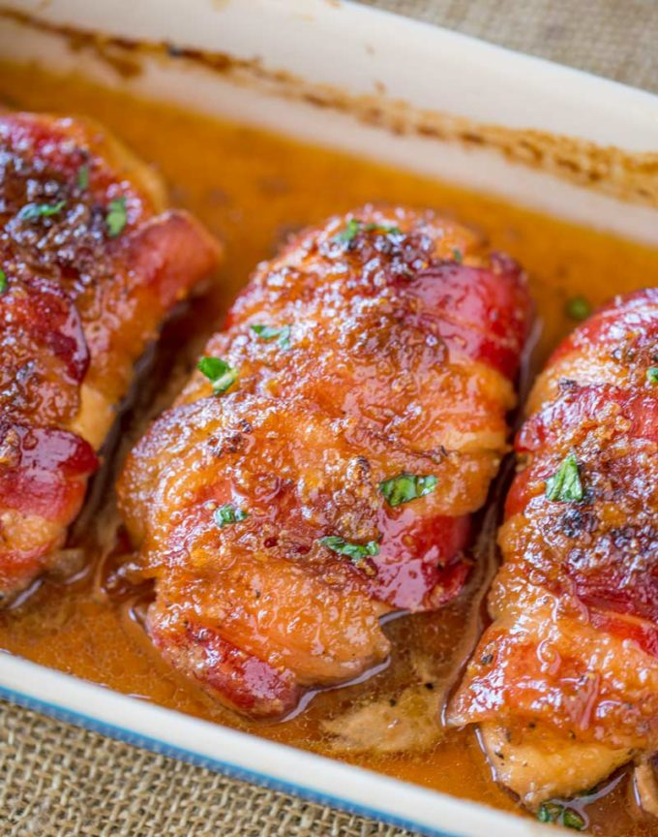
Prep Time 5 min Cook Time 25 min
2 Servings
Ingredients
1/3 cup brown sugar packed
1 tablespoons garlic minced
¼ teaspoon kosher salt
¼ teaspoon black pepper
2 boneless skinless chicken breasts
4 slices bacon
Directions
- I n a large bowl, add the brown sugar, garlic, salt and pepper and mix until combined.
- Coat the chicken in the brown sugar mixture.
- Wrap each piece of chicken with two slices of bacon (aim for the end of the bacon pieces to stay under the chicken to prevent unwrapping while cooking).
- Place into your baking pan with at least 2 inch high sides.
- Top with the remaining brown sugar mixture.
- Cook at 375 degrees for 19 minutes convection oven (25-30 minutes oven) or until cooked through and browned.
- Careful to not let the brown sugar burn and blacken.
Notes
Check the chicken at 25 minutes, you want to catch this when it is browned but not blackened and with sugar that can sometimes turn quickly.
Add in 1/2 teaspoon of crushed red pepper or a squirt of Sriracha to make it spicier
If you want an even deeper caramel flavor, try dark brown sugar.

